THE MAKING OF URBAN SPACES IN CHINA: A CASE STUDY OF THE LINGUISTIC LANDSCAPE OF A SHANGHAI BUS LINE
Mary Rose Brooks
ABSTRACT:
Urban spaces are shaped by the text within them, which is in turn shaped by the purpose of the space and the people and groups who form the text. A bus line functions as a linguistic landscape that is not constrained to one physical location but nevertheless is a physical structure, intraconnected. Studying the linguistic landscape of a bus line offers a chance to view the interplay of different forms of text within a municipally managed public urban space. This study analyzed the linguistic landscape of the 960 bus line in Shanghai, China through the text present at the 960’s forty-five bus stops, using diachronic data collection. It was found that
Conceptual Framework: Urban Space Making, Mobility, and the Linguistic Landscape
In urban spaces, meaning is created by and within systems of mobility. Structures of mobility can be understood in terms of “armatures” and “enclaves” (Jensen 140). “Armatures” can be defined as the connecting pathways of a city – for example, a sidewalk or a bus line. “Enclaves” can be defined as-contained areas distinct from armatures that are “sites of friction and relative slowness” (140) – for example, a street intersection or a bus stop. The population of a city also constitutes its structure: people do not just move through the structure of a city as a separate entity; they are “producing and re-producing the city and the self” through interaction with the system of mobility (Jensen 152). Structures of mobility code and are encoded by systems of human behavior (146), which are in turn influenced by varying levels of social power that groups and individuals hold (147). The physical characteristics of systems of mobility, like most components of the urban landscape, are largely formed by municipal and corporate authorities (Assaf-Zacharov and Schnetgöke, 179).
The linguistic landscape is another key aspect of urban space making. The concept of a linguistic landscape (hereafter referred to as ‘LL’) was first defined by Landry and Bourhis in 1997 as ““the language of public road signs, advertising billboards, street names, place names, commercial shop signs, and public signs on government buildings” (Landry & Bourhis, 25). Language usage in public space can reveal how the language policies and ideologies of a certain society function, which makes the LL a valuable area of analysis in linguistic and urban anthropology research (Yao et al 307). LL studies have been a quickly growing field in past decades; as research in the field has progressed, the definition of the LL has since been expanded to include “unofficial” or impermanent text, such as graffiti, stickers, etc. (Moriarty 459).
Researchers have advocated in recent years for linguistic analysis that considers systems of mobility, or “spatially interested sociolinguistics” (Karlander, 41). As Moriarty points out, Landry and Bourhis’ original research fails to take into consideration the “dynamic, fluid and ever-changing” (Moriarty 458) nature of the LLs in question; LL researchers can apply the conceptual frameworks of systems of mobility to LL research to address this need (458). Several scholars have conducted research on the LLs of different public transportation systems in cities worldwide, such as Karlander’s work with the Stockholm metro, Butcher’s work with the Delhi metro, and Cockain’s work with the Shanghai metro. A point of note is that much of the research on the LLs of public transportation concerns metro systems in cities where the metro (or subway) is the primary method of public transportation. Relatively few focus on less prominent forms of public transportation such as bus lines, which have different experiential conventions from metro lines (e.g. lack of security checkpoints at each stop) and so offer new avenues of LL research.
A distinction often made in LL studies is the difference between “top-down” and “bottom-up” language practices (Yao et al 307). Within this distinction, “top-down” language is placed on the LL by corporate or government authorities, and “bottom-up” language is placed by individuals or smaller businesses (307). Although language policy is overwhelmingly formed by top-down sources, bottom-up language practices often become de facto policy (307). Much LL research has focused on top-down language policy, but in recent years LL research has shifted to focus on language policy created by bottom-up social practices and discourse – that is, de facto language policy (Wang et. al. 300).
The permanency or impermanency of text in the LL can be a key metric in LL research. Permanent or durable text can often be inferred to hold prestige status in the LL, while impermanent text can often be inferred to hold inferior status (Shang, Zhou 41). Non-official/bottom-up text is often purposefully removed in order to regulate LLs and maintain “neat and orderly urban space” (Karlander 43); permanency can, therefore, be based on the source rather than the physical material of the text. In most Chinese cities, for example, “小广告” or “little advertisements” – small impermanent advertisements, usually consisting of a phone number and sometimes a service – are placed all over the cityscape by individuals and routinely removed or pasted over by authorities (Zhang 157). A diachronic approach – that is, studies where data is collected from the same physical area over multiple points in time – is often used to measure the permanency of texts. Due to the time consuming and resource-intensive nature of diachronic research, many LL studies are synchronic, with data being collected from a physical location at only one point in time. Synchronic studies can, however, often infer permanency from the context and physical material of the text in question – a street sign made of metal is more durable than a paper flyer. Due to its transient nature, data on impermanent text is often much harder to collect than data on permanent text, making LL studies including impermanent text data comparatively few (Shang, Zhou 38, 45). This study will employ a diachronic approach to evaluate both permanent and impermanent text in order to contribute to these comparatively little-researched fields.
Another metric that can reveal the prestige status of different languages, scripts, or registers in a LL is a language’s salience on signs. “Salience” refers to the placing and/or size of language on signs to emphasize or deemphasize the text (Han, Wu 9). How the salience of a language is calculated can depend on the orientation norms of that language – for example, in a language that orients left-right, language to the left would be in a salient position (9) but in a language that orients right-left, the text on the right would be in a salient position. In LLs with multilingual signage, observing the salience of different languages in different contexts can reveal insights about how these languages are used and valued in these contexts (9).
In their study of multilingual signage in the city of Guangzhou, Han and Wu implement a “triad model,” adapted from Trumper-Hecht’s 2010 study of residents’ perception of the LLs of cities in Israel, which was itself adapted from Lefebvre’s 1991 The Production of Space. The triad model conceptualizes the LL in terms of three dimensions: the spatial dimension, the political dimension, and the experiential dimension (2). The physical dimension consists of the data and characteristics of the LL; the political dimension consists of the language ideologies and practices of social groups with the most power over the LL (e.g. politicians, city planners), or, rephrased, “top-down” language ideologies; the experiential dimension consists of the language ideologies and practices of the public, or, rephrased, “bottom-up” language practices (2). These spheres sometimes overlap and sometimes contradict each other; by studying these overlaps and contradictions in the LL, a researcher is able to get a much clearer picture of the dynamics of language in a given society (3). As with Lefebvre’s original usage of the model, exploring where practice conforms to policy and where there is “dissonance between representation and practice” (Cresswell 20) in the context of even non-linguistic urban anthropology can reveal how different groups negotiate social structures in urban spaces. In an example of this framework in practice, through his observation of the Shanghai metro Cockain noted moments of dissonance between passengers’ practices and regulatory signs: signs instructing passengers to refrain from looking at their mobile phones while on the escalator are summarily ignored by many in small acts of civil disobedience (Cockain 545-546).
Context: Language Policy in China
There has been a substantial increase in recent decades of anthropological scholarship in China in the wake of the country’s political shifts (Harrell 139), making anthropological studies in China part of a quickly developing field. As a country whose government has a history of advancing societal changes through mass visual media campaigns (Zhang 160-168) as well as advancing substantial language and script reforms in the last century, LL study in China is of particular interest. As Zhengsheng Zhang puts it in his book Chinese Signs: an Introduction: “signs are barometers of changing times” (Zhang 3).
Simplified Chinese writing is used in mainland China and was assiduously promoted by the state in the early stages of the development of the P.R.C.. According to Article 17 of the P.R.C.’s Chinese language law, traditional characters should only be used in situations such as historical sites and calligraphy; according to Article 14, “TV or movie scripts, signage and advertisements should use standardized Chinese characters” (Han, Wu 7). Nevertheless, Chinese advertisements and other public signage nowadays occasionally use traditional characters, often written in calligraphic fonts to fall under the “calligraphy” heading covered by Article 17 and avoid censorship (7). Interestingly, younger, southern coastal cities (such as Shanghai, Shenzhen) tend to have a higher percentage of traditional characters in their LLs than older northern cities (such as Beijing, Xi’an) (10). In addition to traditional characters, Chinese signs often include elements of classical/literary Chinese, all intended to convey learnedness, prestige, or cultural nostalgia (Zhang 4-5, 37-38). These elements are often used in conjunction with colloquial language (77). For example, Chinese signs conveying warnings, reminders, and rules tend to use classical characters to convey seriousness: for example, the usage of the classical character “勿,” or “do not” in the commonly seen phrase “请勿,” or “please do not” (128). It is worth noting the difference between the terms “traditional” and “classical/literary” when referring to Chinese writing – “traditional” writing refers to the characters used in the P.R.C. pre-20th century script reforms, while “classical/literary” writing refers broadly to the vocabulary and grammar used in the classics of Chinese literature (which were, of course, originally written in traditional characters).
Another notable language policy in the P.R.C.’s history is the enforced precedence of Mandarin over other Chinese dialects (Han, Wu 7-8), of which the standardization of the writing system plays a part. Most dialects (with the notable exception of Cantonese) do not have their own official writing system, and are only conveyed through Chinese characters (Zhang 169). In theory, Chinese characters are ideographic, and so should be able to be used to convey meaning in different dialects despite phonetic differences. The reality, however, is that Chinese characters rely on grammatical organization and concepts/words that other Chinese dialects simply do not have and are often unable to convey concepts that are present in non-Mandarin dialects. Additionally, the practice of the Rebus principle means that ideographic characters are used to represent words in other Chinese dialects not ideographically, but phonetically (Zhang 169). For example, the usage of the character “宁” (níng) to represent a Shanghainese word with the same sound; in Mandarin, “宁” means “peace,” but in Shanghainese “宁” means “person” and is more equivalent to the Mandarin character “人” (rén) (172). In the wake of the Chinese government’s recent motions towards support of dialect preservation, dialect writing can sometimes be found in China’s LLs to varying rhetorical purposes: appealing to cultural tourism, preserving local culture, etc. (Han, Wu 7-8). However, the national language law still contains several articles restricting the usage of dialect in public writing and broadcasting (7). Dialect writing is more common in wealthier, southern coastal cities, where there are stronger networks of dialect preservation (especially in Yue Chinese speaking areas) (8). Many Chinese cities also have a large amount of English on public and private signage (3), as well as Romanized Chinese, in pinyin or other romanization systems (4). Both pinyin/other Romanized Chinese and English are intended for foreign visitors or residents. Romanized Chinese is legible to any individual that can read the roman alphabet, but the meaning is usually illegible to anyone that does not understand Mandarin (9).
METHODOLOGY:
Focusing on the political and physical dimensions of the triad model of LL analysis, this study collected data from the LL of Shanghai’s bus system. Special attention was paid to where there is dissonance between the physical and political dimensions, as well as where there is agreement.
For the political dimension, language planning and public transportation administration regulations were examined from Shanghai’s “Regulations of Shanghai Municipality on the Administration of Passenger Transport by Bus, Tram and Trolleybus,” and “Provisions of Shanghai Municipality on Investigating and Punishing Unwarranted Posting, Drawing, Carving, Hanging or Distributing.”
For the physical dimension, the dataset consists of photographs of “signs” (ranging from business cards stuck in or on bus stop structures to schedule screens) present on each of 45 stops on the 960 bus line. Although data was collected following the 960 route, the stops are often part of multiple lines, such as the 559, 69, 317, etc., and so the data is not limited to only the 960. Data was collected diachronically, with an interstice of one month. From the 45 bus stops, 928 individual “signs” were recorded from the sum of both rounds of data collection. To process the data, each of these 928 signs was coded with relevant variables. The variables used are separated into categories and explained below, with visual examples of corresponding signs:
LEGIBILITY:
Blank: Signs that are completely blank; blank sticker residue (peeled off, weathered away, or painted over)
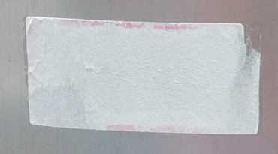
Figure 1. An example of a blank sign

Non-Blank: Signs that are completely or partially legible
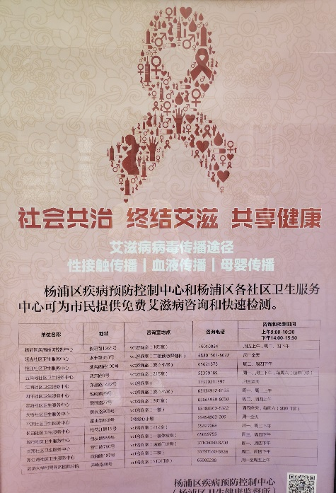
Figure 2. An example of a non-blank sign
PERMANENCY:
Durable: Signs made of durable materials (metal, hard plastic, electronic screen, protected behind glass, etc.)
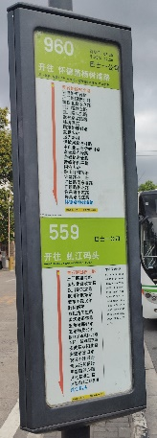
Figure 3. A durable sign

Non Durable: Signs made of non-durable materials (paper, stickers, etc.)
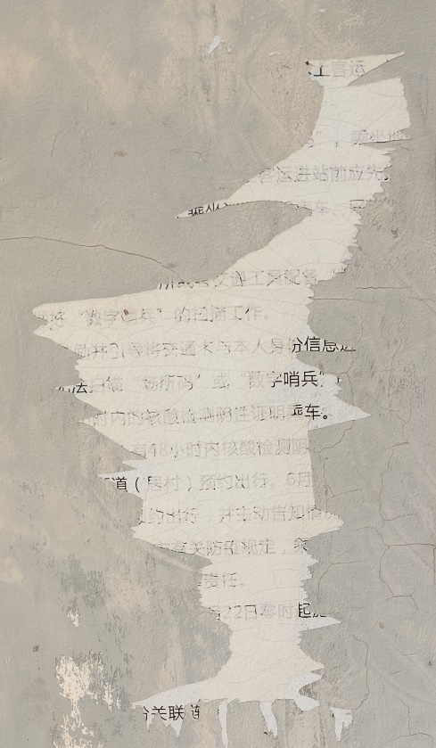
Figure 4. A non-durable sign
LANGUAGE:
Simplified Chinese: Signs with Simplified Chinese writing on them
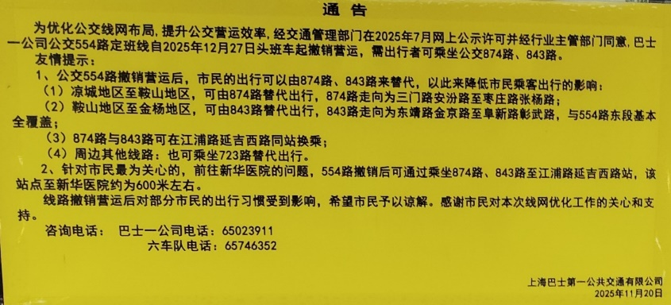
Figure 5. A sign with simplified Chinese

Pinyin: Signs with pinyin (the official way to Romanize Mandarin in China) on them
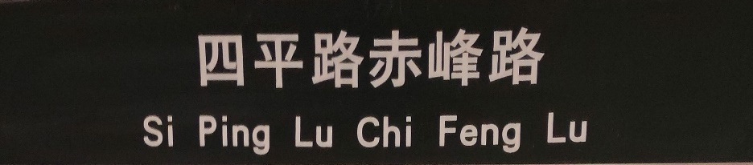
Figure 6. A sign with pinyin

Traditional Chinese: Signs with Traditional Chinese writing on them

Figure 7. A sign with Traditional Chinese writing

English: Signs with English writing on them

Figure 8. A sign with English
PURPOSE:
Advertisement: Signs whose purpose is advertisement

Figure 9. An advertisement sign

Civic: Signs whose purpose is promoting civic values, providing public service information (e.g. health center locations, anti-fraud numbers), or promoting municipal campaigns; what the “Regulations of Shanghai Municipality on the Administration of Passenger Transport by Bus, Tram and Trolleybus” calls “advertisements of public interests”

Figure 10. A civic sign

Functional: Signs whose purpose is providing functional information about transit times, bus stop location, etc.
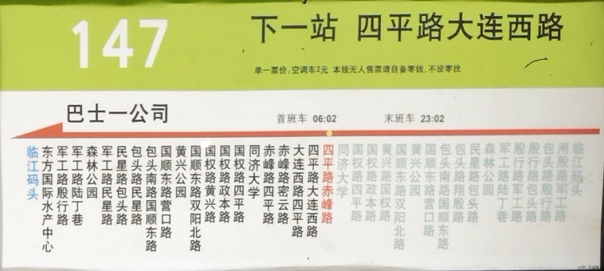
Figure 11. A functional sign

Miscellaneous: Signs whose purpose falls into none of the above categories

Figure 12. A miscellaneous sign
TEXT DATA:
While the proportion of blank to non-blank signs stayed relatively the same in between round 1 and 2 of data collection (Table 1, Table 2), a substantial portion of blank non-durable signs (all sticker residues) from round 1 were scraped away with by round 2 (Table 4), and new blank stickers appeared (Table 2). 41.46% (17 out of 41) of the blank stickers from round 1 were removed, while none of the blank durable signs were removed (Table 3, Table 4).
Additionally, the majority of the blank/illegible signs from round 1 (85.42%) were also non-durable (Table 3), forming a strong correlation between non-durability and illegibility, which supports Shang and Zhou’s claims about the fleeting nature of much impermanent text (Shang, Zhou 38).
Table 1. Legibility of signs at round 1 of data collection
Round 1 | Number | Percentage
Blank | 48 | 6%
Non Blank | 752 | 94%
Total | 800 | 100%
Round 2 | Number | Percentage
Blank | 49 | 6.19%
Non Blank | 743 | 93.81%
Total | 792 | 100%

Table 2. Legibility of signs at round 2 of data collection

Table 3. Legibility and durability of signs at round 1 of data collection
Round 1 | Number | Percentage
Blank + Non-Durable | 41 | 85.42%
Blank + Durable | 7 | 14.58%
Total Blank | 48 | 100%

Table 4. Removal of signs in between round 1 and 2 of data collection – legibility/durability
REMOVAL Round 1 to 2 | Number | Percentage
Blank + Non-Durable | 17 | 100.00%
Blank + Durable | 0 | 0%
Total REMOVAL Blank | 17 | 100%

While the proportion of durable to non-durable signs stayed relatively the same in between rounds 1 and 2 (Table 5, Table 6), a point of interest is the percentage of functional non-durable signs (i.e., stickers and flyers that were placed by transit authorities and provide functional information about the bus stops) that were removed compared to the percentage of non-functional non-durable signs (e.g., small individual advertisement stickers) that were removed. Although functional non-durable signs and non-functional non-durable signs are each roughly half of the total non-durable signs (43.68% and 56.32%, respectively) (Table 7), non-functional non-durable signs make up a disproportionate number of the total non-durable signs that were removed (90.91%, compared to 9.09% of functional non-durable removals) (Table 8). Given that the majority of the stickers removed were non-official, this coincides with Karlander’s observations about the deliberate removal of unofficial text to maintain semiotic normality (Karlander 43), even when the material of the official and nonofficial text was similar.
Table 5. Durability of signs at round 1 of data collection
Round 1 | Number | Percentage
Durable | 713 | 89.12%
Non Durable | 87 | 10.88%
Total | 800 | 100%

Table 6. Durability of signs at round 2 of data collection
Round 2 | Number | Percentage
Durable | 709 | 89.52%
Non Durable | 83 | 10.48%
Total | 792 | 100%

Table 7. Durability and functionality of signs at round 1 of data collection
Round 1 | Number | Percentage
Functional + Non-Durable | 38 | 43.68%
Non-Functional + Non-Durable | 49 | 56.32%
Total Non-Durable | 87 | 100%

Table 8. Removal of signs in between rounds 1 and 2 of data collection – durability/functionality
REMOVAL Round 1 to 2 | Number | Percentage
Functional + Non-Durable | 2 | 9.09%
Non-Functional + Non-Durable | 20 | 90.91%
Total REMOVAL Non-Durable | 22 | 100%

Between rounds 1 and 2 of data collection, the percentage of advertisement signs decreased from 14.76% in round 1 to 9.67% in round 2, with a corresponding increase of civic signs from 43.88% to 49.01% (Table 9, Table 10). Advertisements also had the highest rate of removal at 72.04% (Table 11). Worth noting for their inability to fit in other categories are the “Miscellaneous” signs; four were recorded across the two rounds of data collection, each transcribed, translated to English and contextualized below (“/” used to indicate a line break):
- “在心里/种花/人生才不/会荒芜” “Plant flowers in the heart, and life will not lie fallow” an inspirational poem
- “我不再过度自省” “I [will] no longer overly criticize myself” an aspirational mantra
- “风祥雨顺/谷果丰登/万姓四民/永安富乐” “Auspicious winds and favorable rains/A bountiful harvest of grain/to ten thousand family names and four peoples/eternal peace, prosperity, and happiness” a series of four-character idioms.
- “南無阿弥陀仏” “Namu Amitabha Buddha” a transliteration of the Japanese Buddhist devotional phrase “Namo Amitabha Buddha” (Ujihira)
Table 9. Purpose of signs at round 1 of data collection
Round 1 | Number | Percentage
Advertisement | 111 | 14.76%
Civic | 330 | 43.88%
Functional | 308 | 40.96%
Advertisement + Civic | 0 | 0%
Miscellaneous | 3 | 0.40%
Total | 752 | 100%

Table 10. Purpose of signs at round 2 of data collection
Round 2 | Number | Percentage
Advertisement | 73 | 9.67%
Civic | 370 | 49.01%
Functional | 305 | 40.40%
Advertisement + Civic | 3 | 0.40%
Miscellaneous | 4 | 0.53%
Total | 755 | 100%

Table 11. Removal of signs in between rounds 1 and 2 of data collection – function
REMOVAL Round 1 to 2 | Number | Percentage
Advertisement | 85 | 72.04%
Civic | 27 | 22.88%
Functional | 6 | 5.08%
Advertisement + Civic | 0 | 0%
Miscellaneous | 0 | 0%
Total REMOVAL | 118 | 100%

From round 1 to round 2, the proportions of each language stayed roughly the same (Table 12, Table 13). It is worth noting that the signs were searched for Shanghainese writing, none was found. This indicates compliance with the language laws stipulating dialect usage in public space (compliance present even in the non-official signs) (Han, Wu 7). The signs that included pinyin in some way in round 1 totaled 130 (17.29%) (Table 12), and 123 (16.29%) in round 2 (Table 13). Although only one sign was entirely in English, the signs that included English in some way in round 1 totaled 93 (12.37%) (Table 12), and 104 (13.77%) in round 2 (Table 13). Worth noting is the presence of traditional signage; slim though it is at .66% of the total in round 1 (Table 12) and a cumulative .39% in round 2 (Table 13), it constitutes a dissonance in a majority Simplified Chinese LL. In every case of Traditional Chinese being present, it was used minimally, with Simplified Chinese constituting the majority of the text on the sign. However, in none of the cases where Traditional Chinese was used was a calligraphic font used to stay within the technical provisions of the law as in the cases Han and Wu observed (Han, Wu 7), which constitutes a more overt dissonance of language laws in Shanghai. In the six instances where Traditional Chinese was used, five of the signs were durable advertisements authorized by transit authorities, and one sign was a non-official sticker placed by an individual.
Table 12. Language of signs at round 1 of data collection
Round 1 | Number | Percentage
Simplified Chinese | 565 | 75.13%
English | 1 | 0.13%
Simplified + Traditional | 0 | 0%
Simplified + English | 51 | 6.78%
Simplified + Pinyin | 94 | 12.50%
Simplified + Traditional+ English | 5 | 0.66%
Simplified + Pinyin + English | 36 | 4.79%
Total | 752 | 100%

Round 2 | Number | Percentage
Simplified Chinese | 561 | 74.30%
English | 2 | 0.26%
Simplified + Traditional | 1 | 0.13%
Simplified + English | 66 | 8.74%
Simplified + Pinyin | 89 | 11.79%
Simplified + Traditional + English | 2 | 0.26%
Simplified + Pinyin + English | 34 | 4.50%
Total | 755 | 100%
Table 13. Language of signs at round 2 of data collection

URBAN SPACE MAKING LAWS:
Shanghai’s “Provisions of Shanghai Municipality on Investigating and Punishing Unwarranted Posting, Drawing, Carving, Hanging or Distributing” controls bottom-up contribution to the LL in Shanghai’s public and private spaces, which includes its bus stops. Article 4 states:
“It is prohibited to arbitrarily post up or hang publicity materials on buildings, structures or other facilities. If it is necessary to temporarily post up and hang publicity materials on buildings, structures or other facilities under particular circumstances, approval shall be obtained from the district administrative department of landscaping and city appearance, and such items shall be posted up or hung within the prescribed time limit and scope, and be cleared away in a timely manner upon the expiration of the time limit” (Article 4).
This law regulates the presence of advertisements in Shanghai’s LL by controlling the content of the advertisements (which require approval from municipal authorities), the scope of the advertisements, and the permanence of the advertisements (the length of time the signs can stay up being determined by the authorities).
Public transportation management in Shanghai has its own set of regulations regarding the management of the systems’ LLs. In a continuation of regulations on advertising, Article 39 states that:
“Advertisements put up on the operating vehicles shall, in addition to conformity with relevant laws and regulations concerning advertisements, comply with relevant provisions for the administration of bus, tram and trolleybus operation regarding the position, size and color of the advertisement”
“No audio advertisements are to be broadcasted, nor are written advertisements to be distributed in the vehicles”
“Where advertisements are put on covered bus stops or stations, the overall area shall not surpass 40% of the three-dimensional area of the covered bus stops or stations, and the proportion of the advertisements of public interests in the aspect of area or time shall not be less than 10% of the total amount of the advertisements” (Article 39).
This article not only regulates stationary components of bus lines’ LLs, but the mobile components constituted by the buses themselves. The regulation of the space granted to advertisements grants corporate authorities some power to shape urban space along the bus lines, but ultimately leaves it to municipal authorities to approve advertisement quality and distribution.
The laws of public transportation management also include regulations on functional text, such as:
“Line operators shall erect signposts, including temporary signposts (similarly hereinafter), at bus, tram and trolleybus stops and stations in accordance with the uniform standard prescribed by the Municipal Transport Administrative Section”
“Bus, tram and trolleybus stop and station signposts shall bear the name of the line, the time for the first and the last run, the name of the stop and names of other stops along the route, the direction in which the vehicle is running, the rates of fare, etc. The signposts shall be conspicuous and be kept in good condition. In the case of lines with vehicles running at intervals of more than 30 minutes, the time of each run passing the stop shall be clearly indicated” (Article 37).
In the case of regulations on functional text, it is made clear that the permanency of these signs is to be maintained, a consideration not granted to other forms of text on the bus lines. Structural text is also held to a more uniform standard than other forms of text in the LL.
CONCLUSIONS:
Shanghai has several regulations concerning the management and maintenance of the LL of its bus lines and of its public spaces in general. National language laws concerning script and dialect visibility also affect the composition of Shanghai’s LL. Individuals and corporations interact variably with these regulations, sometimes conforming their language practices to the letter of the law, and sometimes performing language practices that contradict the rules set in place. In the case of Shanghai’s bus line 960, they do this in how they use different languages/scripts, the placement/removal of different signs, and the purpose of the signs.
The majority of the signs on the 960 line comply with the requirement to use Simplified Chinese on public signs, but a few include only English in a violation of this requirement. Additionally, a few signs include non-calligraphic Traditional Chinese in violation of China’s national language law regulations of the usage of Traditional Chinese in public signage. This noncompliance is present from both individual (bottom-up) sources and corporate/municipal (top-down) sources, making the dynamics more complex than a simple top-down vs. bottom-up dichotomy. In the realm of dialect writing, however, the LL demonstrates compliance with the national language law. Despite the fact that there exists a system for Chinese characters being used to write Shanghainese, and despite Shanghai’s status as a relatively wealthy southern city with more advocacy over dialect preservation as a result, none of the signs in the data set included any Shanghainese writing. In this way, even though small challenges to the omnipresence of Simplified writing were present, the dominance of Mandarin as the official language of China goes uncontested in the 960 line’s LL.
Despite the regulations on Shanghai’s LL in general and the LL of its bus lines in particular requiring advertisements to be approved by municipal authorities and taken down after a predetermined amount of time, there are many instances of non-official sticker advertisements that were placed arbitrarily on the bus stops by individuals, some eventually removed. As the stickers and other impermanent text are removed, however, they are continually replaced by other stickers etc., maintaining their role in the LL. Miscellaneous signs, which are neither advertisement, not civic value signs, nor official structural signage occupy a legal gray area that gives them a special place in the LL. Poems, good-luck idioms, and Buddhist mantras do not fall under the category of “unofficial advertisements” that the regulations surrounding Shanghai’s LL focus on, but are nevertheless arbitrarily placed on the LL by unofficial sources.
LIMITATIONS AND SUGGESTIONS FOR FURTHER RESEARCH:
Due to my limited proficiency in Mandarin Chinese at the time research was being conducted, I opted not to conduct interviews with bus stop users for fear of misrepresenting and/or misunderstanding their answers. Future research might include ethnographic interviews to provide data on the experiential aspect of the LL. Additionally, this limited proficiency means that some nuances of written meaning have likely been overlooked. Although I found no Shanghainese in the LL, this might simply be my lack of proficiency beyond very basic Shanghainese; I may have overlooked Shanghainese text that was in fact present.
Due to time constraints, the salience of different languages in Shanghai’s LL was an unexplored factor that could lend further insights into the role of these languages. Relatedly, although this study was conducted diachronically, it was conducted over a relatively short timeframe. Studies that conduct diachronic research over a large timeframe and/or with more than two rounds of data collection could yield further insights into the fluidity of Shanghai’s LL.
This study is limited to single bus line spanning two city districts in a single city. This leaves much room for comparative research to be done using data from multiple districts in a single city, or in multiple cities. Comparative research could also be done across different forms of transportation, given that each form can have different experiential conventions.

WORKS CITED
Assaf-Zakharov, Katya, and Tim Schnetgoke. “Un)Official Cityscapes: The Battle over Urban Narratives.” Harvard Civil Rights-Civil Liberties Law Review, vol. 57, no. 1, June 2022, pp. 177–270. EBSCOhost, research.ebsco.com/linkprocessor/plink?id=76fdc3c8-98be-3367-a975-9f43ce07d38e.
Butcher, Melissa. “Cultures of Commuting: The Mobile Negotiation of Space and Subjectivity on Delhi’s Metro.” Mobilities, vol. 6, no. 2, May 2011, pp. 237–54. EBSCOhost, https://doi.org/10.1080/17450101.2011.552902.
Cockain, Alex. “Riding and Reading the Shanghai Metro: Signs, Subjectivities and Subversions on and around Line # 8.” Social Semiotics, vol. 28, no. 4, Sept. 2018, pp. 533–54. EBSCOhost, https://doi.org/10.1080/10350330.2017.1366392.
Cresswell, T. “Towards a Politics of Mobility.” Environment and Planning D: Society and Space.” vol. 28, no. 1, Jan. 2010, pp. 17-31–31. EBSCOhost, https://doi.org/10.1068/d11407.
Han, Yanmei, and Xiaodan Wu. “Language Policy, Linguistic Landscape and Residents’ Perception in Guangzhou, China: Dissents and Conflicts.” Current Issues in Language Planning, vol. 21, no. 3, Jan. 2020, pp. 229–53. EBSCOhost, https://doi.org/10.1080/14664208.2019.1582943.
Harrell, Stevan. “THE ANTHROPOLOGY OF REFORM AND THE REFORM OF ANTHROPOLOGY: Anthropological Narratives of Recovery and Progress in China.” Annual Review of Anthropology, vol. 30, no. 1, Oct. 2001, p. 139. EBSCOhost, https://doi-org.proxy.library.umkc.edu/10.1146/annurev.anthro.30.1.139.
Jensen, Ole B. “Flows of Meaning, Cultures of Movements - Urban Mobility as Meaningful Everyday Life Practice.” Mobilities, vol. 4, no. 1, Mar. 2009, pp. 139–58. EBSCOhost, https://doi.org/10.1080/17450100802658002.
Karlander, David. “Backjumps: Writing, Watching, Erasing Train Graffiti.” Social Semiotics, vol. 28, no. 1, Feb. 2018, pp. 41–59. EBSCOhost, https://doi.org/10.1080/10350330.2016.1200802.
Rodrigue Landry, and Richard Y. Bourhis. “Linguistic Landscape and Ethnolinguistic Vitality: An Empirical Study.” Journal of Language and Social Psychology, vol. 16, Mar. 1997, pp. 23–49. EBSCOhost, https://doi.org/10.1177/0261927x970161002.
Lefebvre, Henri. The Production of Space / Henri Lefebvre ; Translated by Donald Nicholson-Smith. Blackwell, 1991. EBSCOhost, research.ebsco.com/linkprocessor/plink?id=889b9402-4bce-3118-897e-233a273fd331.
Li Muzi, Wang Shuaichen. "Pluralistic Construction and Cultural Identity of Rail Transit Language Landscape". Global Social Science Review, Vol. 2, No. 5, October 2025, pp. 17-22, https://doi.org/10.62836/ssr.v2n5.0721.
Moriarty, Máiréad. “Languages in Motion: Multilingualism and Mobility in the Linguistic Landscape.” International Journal of Bilingualism, vol. 18, no. 5, Oct. 2014, pp. 457–63. EBSCOhost, https://doi.org/10.1177/1367006913484208.
“Provisions of Shanghai Municipality on Investigating and Punishing Unwarranted Posting, Drawing, Carving, Hanging or Distributing.” International Services Shanghai. December 25, 2024. Provisions of Shanghai Municipality on Investigating and Punishing Unwarranted Posting, Drawing, Carving, Hanging or Distributing_Bulletin
“Regulations of Shanghai Municipality on the Administration of Passenger Transport by Bus, Tram and Trolleybus.” International Services Shanghai. May 14, 2020. Regulations of Shanghai Municipality on the Administration of Passenger Transport by Bus, Tram and Trolleybus_Local Rules
Shang Guowen, and Zhou Xianwu. "Types, Characteristics, and Research Perspectives of Atypical Language Landscapes." Language Strategy Research 5.4 (2020): 37-47.
Shu, Fang. “A Study of the Linguistic Landscape in Historical and Cultural Districts.” Chinese Traditional Culture 13 (2025): 170. 10.12677/cnc.2025.13202
Ujihira, Akira. “How to pronounce” 南無阿弥陀仏”.” 雲雀野 No. 36, p. 1-12. Published 31 March 2013. Toyohashi University of Technology Academic Institution Repository
Wang, X., Juffermans, K. & Du, C. “Harmony as language policy in China: an Internet perspective.” Lang Policy 15, 299–321 (2016). https://doi.org/10.1007/s10993-015-9374-y
Jiazhou Yao, et al. “Language Change and Multilingualism in an Ethnic City in China: A Diachronic Linguistic Landscape Perspective.” International Journal of Multilingualism, vol. 22, no. 2, Jan. 2025, pp. 592–609. EBSCOhost, https://doi.org/10.1080/14790718.2024.2322472.
Zhang, Zheng-sheng. Chinese Signs: An Introduction to China’s Linguistic Landscape. Cambridge University Press, 2024.

In reality, many “dialects” in China are mutually unintelligible enough from Mandarin and from each other that they constitute different languages; many argue that “dialect,” then, is a political designation (Han, Wu 4). Nevertheless, it is the most commonly used term in academic discussion, so for the sake of convenience “dialect” is the term that this paper will use.
By the author of this paper
Blank signs were excluded from the totals in tables concerning “purpose” and “language,” as no relevant variables apply to blank signs

