Accuracy of Coronal Implant Positioning in Robotic-Assisted Total Knee Arthroplasty: A Comparative Study of MAKO, ROSA X-ray, and ROSA Imageless Systems
Angelina Mei Kwan^{1,2}, Daisuke Fukui¹, Daisuke Nishiyama¹, Manabu Yamanaka¹, Tsuyoshi Deguchi¹, Yuta Kaimochi¹, Koichi Masuda², Morihiro Tonoo³, Hiroshi Yamada¹
1 Department of Orthopaedic Surgery, Wakayama Medical University, 2 Department of Orthopaedic Surgery, University of California San Diego,
3 Department of Orthopaedic Surgery, Kishigawa Rehabilitation Hospital
Disclosures: Angelina Mei Kwan (N), Daisuke Fukui (N), Daisuke Nishiyama(N), Manabu Yamanaka (N), Tuyoshi Deguchi (N), Yuta Kaimochi (N), Koichi Masuda (N), Morihiro Tonoo (N), Hiroshi Yamada (N)
INTRODUCTION: Total knee arthroplasty (TKA) is the standard treatment for advanced stage knee osteoarthritis. Robotic-assisted total knee arthroplasty (RATKA) uses robots to achieve greater accuracy and improved surgical outcomes. The use of surgical robots for TKA is becoming increasingly popular due to their potential to improve accuracy in implant alignment¹. Two popular robotic-assisted surgical systems for TKA are the MAKO model by Stryker and the ROSA model by Zimmer-Biomet. The primary distinction between these is that the MAKO model incorporates an attached bone saw and haptic feedback while the ROSA model provides a cutting guide where a hand-held bone saw is applied. The MAKO system utilizes preoperative CT-based planning combined with haptic-assisted bone resection, while the ROSA system offers multiple planning options, including X-ray-based and imageless (intraoperative landmark-based) methods. Although both systems are designed to improve accuracy, their different between robotic system and planning methods may influence implant alignment. Previous studies have found no significant difference in joint line height restoration between the MAKO TKA and ROSA TKA systems (Xray-based)², but direct comparisons of coronal implant positioning among CT-based, x-ray-based, and imageless robotic systems remain limited. Therefore, the aim of this study was to compare the accuracy of coronal implant positioning among three robotic-assisted TKA groups: MAKO (CT-based), ROSA X-ray based, and ROSA imageless systems.
METHODS: Study type: Retrospective Observational Study
Institutions and Implant: At Kishigawa Rehabilitation Hospital, the MAKO system was used with Triathlon PS type implants, and at Wakayama Medical University Hospital, the ROSA system was used with Persona PS type implants.
Patient Population: 165 knees (110 female, 55 male) from 122 patients who underwent RATKA using either the MAKO system or ROSA (X-ray base, or Imageless) between April 2023 and April 2025 were included. Patient characteristics including age, sex, BMI and K-L grade were accounted for. All procedures were performed by two board-certified orthopedic surgeons specializing in joint arthroplasty. Cases with ipsilateral total hip arthroplasty (THA) or total ankle arthroplasty, revision TKA, significant bone deformation, post-traumatic arthritis, and inadequate radiographs were excluded from this study.
Grouping of Study Cohorts: Patients were divided into three groups according to the robotic system and planning method used: MAKO group: Patients who underwent TKA with the MAKO system (CT-based planning). ROSA X-ray based group: Patients who underwent TKA with the ROSA system using X-ray-based preoperative planning. ROSA imageless group: Patients who underwent TKA with the ROSA system using imageless (intraoperative landmark-based) planning.
Surgical Technique and Intraoperative Gap Assessment: Surgical exposure was achieved using a medial parapatellar approach. Following standard exposure, the medial collateral ligament was preserved as much as possible, with minimal subperiosteal release only when necessary to facilitate soft tissue balancing. Initial gap values were measured using navigation-assisted sensors at four key locations: the medial and lateral in extension and 90° of flexion. These measurements were used to optimize the implant position by adjusting the femoral coronal component’s alignment and rotation along with the tibial coronal component’s position and posterior slope.
Evaluation of Implant Alignment: To assess the accuracy of implant positioning, long-leg standing radiographs were obtained 2 weeks postoperatively. The LDFA and MPTA were measured on PACS. The coronal differences between the planned implant positions and the actual postoperative femoral and tibial implant angles were calculated and compared among the three groups. Absolute deviations from planned alignment were defined as component implant positioning errors. The proportion of cases within the acceptable error range (±3°) was also evaluated.
RESULTS SECTION:
Patient Characteristics: The study included 67 knees in the MAKO group, 51 knees in the ROSA X-ray based group, and 47 knees in the ROSA imageless group. Preoperative demographics are shown in Table 1. Slight differences in BMI and K-L grade were found between the MAKO and ROSA systems.
Accuracy of Implant Positioning: Femoral components: Absolute angular errors (AAE) were 1.23 ± 0.14 (MAKO), 1.62 ± 0.16 (ROSA X-ray), and 1.68 ± 0.17 (ROSA imageless), with no significant differences among the groups. Tibial components: AAE were 1.04 ± 0.11 (MAKO), 1.57 ± 0.12 (ROSA X-ray), and 1.12 ± 0.13 (ROSA imageless), showing significantly larger errors in the ROSA X-ray group compared with the other two (Figure 1).
Proportion of Outliers (AAE >3°): Femoral components: No significant differences among groups. Tibial components: Outlier rates were 1.49% (MAKO), 2.13% (ROSA imageless), and 13.73% (ROSA X-ray), with the ROSA X-ray group showing a significantly higher proportion of outliers (Figure 2).
DISCUSSION: This study demonstrated that the ROSA X-ray-based system showed inferior accuracy in tibial alignment compared with both the MAKO (CT-based) and ROSA imageless systems, while femoral accuracy was comparable across all groups. Notably, no difference was observed between MAKO and ROSA imageless, suggesting that the method of bone resection—robot-controlled (MAKO) versus surgeon-controlled manual sawing (ROSA)—is unlikely to affect implant alignment accuracy. The lower accuracy of the ROSA X-ray based system likely reflects the limitations of converting two-dimensional radiographs into three-dimensional intraoperative references, where registration errors may occur. By contrast, the imageless system avoids this conversion by directly tracking multiple osseous landmarks intraoperatively, allowing for more precise construction of the mechanical axis.
It should be noted, however, that all procedures in this study were performed by surgeons highly experienced in TKA. This may have reduced variability in identifying bony landmarks during imageless registration, contributing to its accuracy. In less experienced surgeons, accuracy might be lower, and X-ray-based planning could provide more consistent results.
SIGNIFICANCE/CLINICAL RELEVANCE: In conclusion, planning modality, rather than the bone resection method, appears to be the primary factor influencing implant alignment accuracy. X-ray-based systems may carry inherent limitations, while imageless and CT-based methods demonstrated comparable precision.
REFERENCES: 1. Kayani B+. Bone Joint Res. 2019. 2. Mayne A+. Orthop Procs. 2023.
IMAGES AND TABLES:
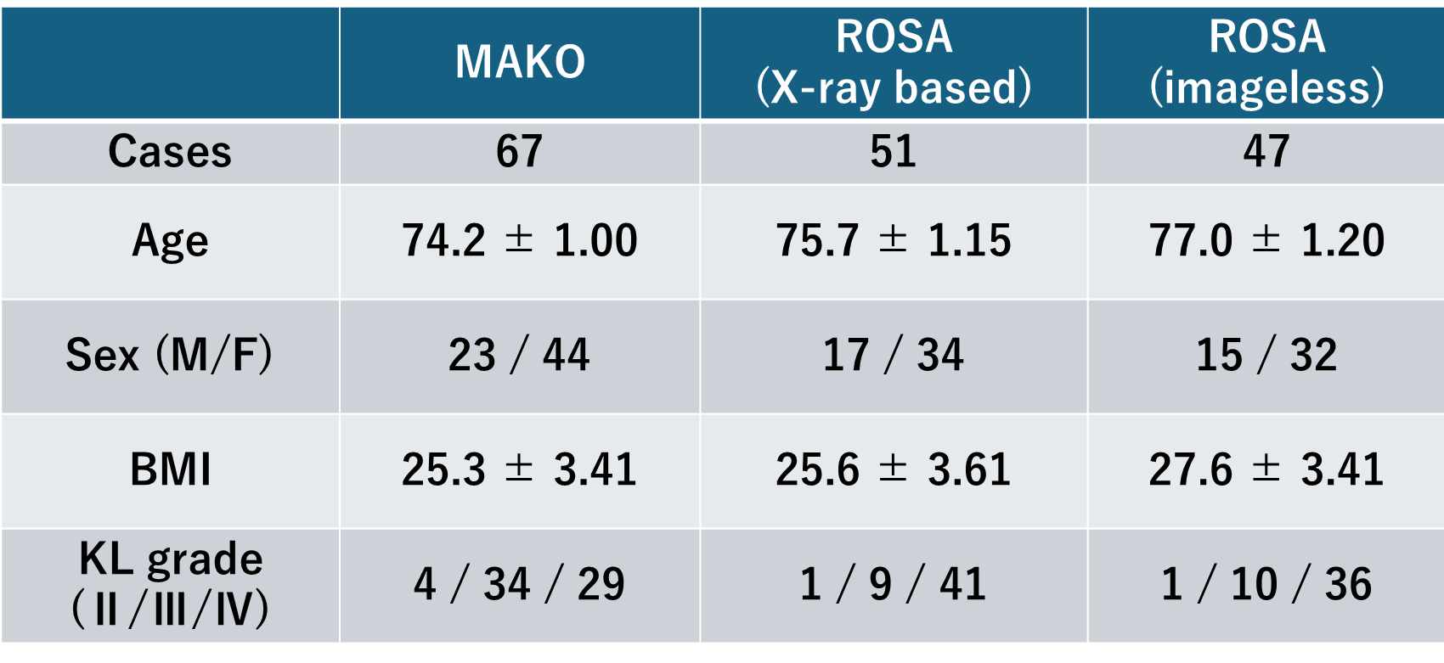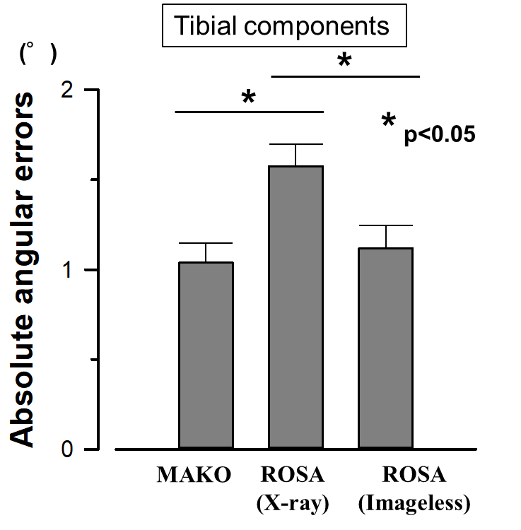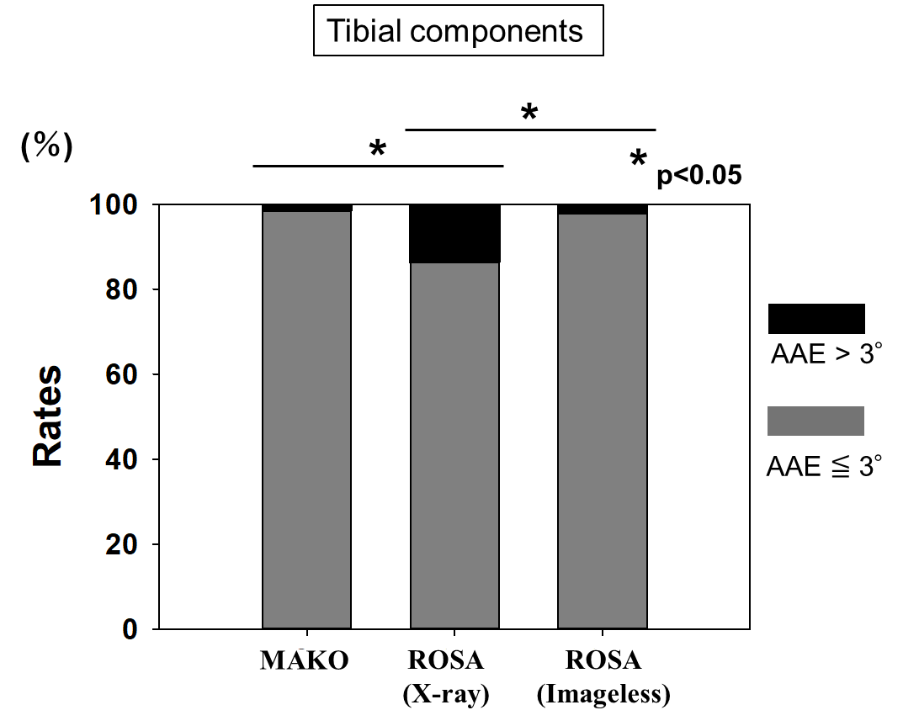
Table 1 Figure1 Figure 2

